Compatibility & Portability Testing

Compatibility Testing

📖 Definition
# Source: Chatgpt (GPT‑5 Mini) at [8/22/2025]
Compatibility Testing checks whether a software application works correctly across different environments, such as:
- Operating systems (Windows, macOS, Linux)
- Browsers (Chrome, Firefox, Safari, Edge)
- Devices (PC, mobile, tablet)
- Networks (3G, 4G, 5G, Wi-Fi)
- Hardware (different CPUs, RAM sizes, GPUs)
👉 In simple words: Does the system behave consistently everywhere it is supposed to run?

🔹 Objectives
# Source: Chatgpt (GPT‑5 Mini) at [8/22/2025]
- Ensure the software works with different configurations and platforms.
- Verify user experience consistency.
- Avoid failures caused by environment mismatches.

🔹 Example (ATM System – Compatibility)
# Source: Chatgpt (GPT‑5 Mini) at [8/22/2025]
- Can the ATM application run on different ATM hardware models?
- Does the web-based ATM management system work on Chrome, Safari, and Edge?
- Does the mobile banking app behave the same on Android and iOS?

🔹 Advantages
# Source: Chatgpt (GPT‑5 Mini) at [8/22/2025]
- Improves market reach (users on all platforms).
- Prevents user dissatisfaction due to environment issues.

🔹 Disadvantages
# Source: Chatgpt (GPT‑5 Mini) at [8/22/2025]
- Time-consuming (many environments to test).
- Requires device labs, virtual machines, or cloud platforms.

Portability Testing

📖 Definition
# Source: Chatgpt (GPT‑5 Mini) at [8/22/2025]
Portability Testing checks how easily software can be transferred or adapted from one environment to another.
It is part of the ISO 25010 software quality model and includes aspects like:
- Installability → How easily can the software be installed on a new system?
- Adaptability → Can it run in a different OS without major changes?
- Replaceability → Can it replace another similar system without issues?
👉 In simple words: How easily can we move the system from one platform/environment to another?

🔹 Objectives
# Source: Chatgpt (GPT‑5 Mini) at [8/22/2025]
- Ensure smooth migration between environments.
- Reduce cost and effort when deploying on new platforms.
- Verify software doesn’t depend on hard-to-change system features.

🔹 Example (ATM System – Portability)
# Source: Chatgpt (GPT‑5 Mini) at [8/22/2025]
- Can the ATM software be installed on a new ATM model with minimal changes?
- Can the banking system move from on-premise servers to cloud without failures?
- Can the mobile banking app be easily ported from Android to iOS?

🔹 Advantages
# Source: Chatgpt (GPT‑5 Mini) at [8/22/2025]
- Helps in scaling software to new platforms.
- Reduces vendor lock-in.

🔹 Disadvantages
# Source: Chatgpt (GPT‑5 Mini) at [8/22/2025]
- May require additional development effort.
- Hard to achieve if software is tightly coupled with one environment.

✅ Key Difference
# Source: Chatgpt (GPT‑5 Mini) at [8/22/2025]
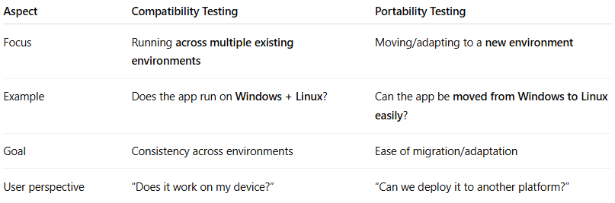
Aspect | Compatibility Testing | Portability Testing
Focus | Running across multiple existing environments | Moving/adapting to a new environment
Example | Does the app run on Windows + Linux? | Can the app be moved from Windows to Linux easily?
Goal | Consistency across environments | Ease of migration/adaptation
User perspective | “Does it work on my device?” | “Can we deploy it to another platform?”

👉 Shortcut to remember:
- Compatibility = Does it work everywhere?
- Portability = Can we move it elsewhere easily?

